RECIPE
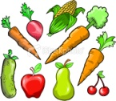
INGREDIENTS
KITCHEN TOOLS
PREPARATION TIME

STEPS | 

